MINISTRY OF SCIENCE AND HIGHER EDUCATION OF THE RUSSIAN
FEDERATION

FEDERAL STATE AUTONOMOUS EDUCATIONAL INSTITUTION OF HIGHER
EDUCATION
"NOVOSIBIRSK NATIONAL RESEARCH UNIVERSITY
STATE UNIVERSITY"
(NOVOSIBIRSK STATE UNIVERSITY, NSU)

09.03.01 - Informatics and Computer Engineering
Focus (profile): Computer Science and system design

TERM PAPER

Authors

Filippova Daria 24216
Muruev Denis 24216
Vilegzhanin Maksim 24216

Job topic:

"Conway Game of life"

Novosibirsk, 2025
Contents
Introduction -------------------------------------------------------------------------------------- 3
Game rules (and additional rules) ------------------------------------------------------- 3
Project Structure --------------------------------------------------------------------------- 4

User manual ---------------------------------------------------------------------------------------5
Hardware ----------------------------------------------------------------------------------------- 7
I/O Interface --------------------------------------------------------------------------------7

Buffers --------------------------------------------------------------------------------------10
Cursor ---------------------------------------------------------------------------------------12

Subschemes --------------------------------------------------------------------------------13
Patterns ------------------------------------------------------------------------------------
Software-------------------------------------------------------------------------------------------15
Memory Sections -------------------------------------------------------------------------15
Main code----------------------------------------------------------------------------------17

Introduction

Our project is based on the CDM-8 platform and the Logisim logic circuit emulator. This is the documentation for the Conway Game of Life project, which was invented by John Conway in 1970.
What is Logisim? Logisim is a logic circuit emulator used mainly for training. It has both simple (AND, OR) and complex (Multiplexers, decoders) logic elements. The CDM-8 was also implemented on the Logisim, which will be discussed later.
What is CDM-8? The CDM-8 is a processor architecture based on the Von Neumann architecture, developed by A. Shafarenko. The CDM-8 is an 8-bit processor of the 2nd level.
We also switched to an extended version of CDM (CDM-8e) during the development process. Why did we do this? In order to increase our ability to expand the code. That is, we did not have enough memory, so we needed additional memory. Increasing the number of memory banks would greatly complicate the readability of the code, as well as slow down its writing.

Game rules (and additional rules)

So, what is the Conway Game of Life? If we consider the game without modifications, then it is a plane placed on the cells, which is often limited or closed. The cells are marked either as alive or as dead.
The generation calculates each cell relative to the previous generation. The calculation takes place according to the following rules:
- If there are 3 or more live cells next to the dead cells (directly next to each other diagonally, vertically or horizontally), then she comes alive.
- If there are 2 or 3 living cells next to a living cell, then it continues to live. Otherwise (3 or more or 2 or less), the living cell dies (either from "loneliness" or from "overpopulation")

Obviously, in order for living cells to appear at all, you need to set the initial state of the field. This condition is called the first generation.

Here you can see an example of cyclic generation. (Fig.1). There are also generations leading to the death of a generation and generations that do not change in time in any way

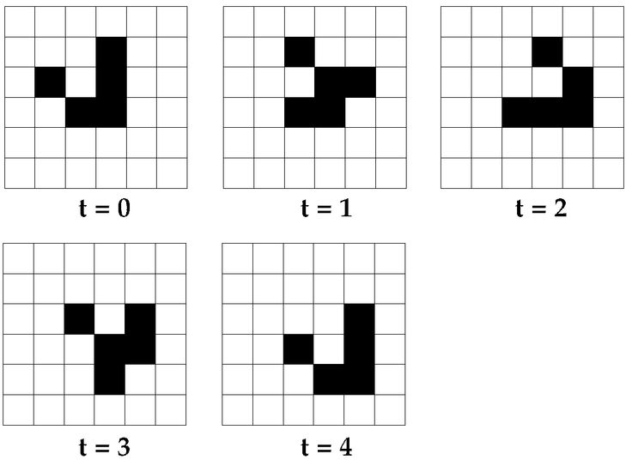
Figure 1

There are several modifications of the game of life in our project, which requires additional explanations.
Firstly, in this game, you can customize the parameters of cell birth and survival in detail. You can specify exactly how many neighbors the cell will "come to life" with. Up to the point that the cell will come to life with any number of living cells around it (not including 0). The same thing works with survival. This parameter is also configured by the user in the game.
Secondly, there are 2 modes in this game. The first is the creative mode. It is a classic Conway's Game of Life (not counting the conditions of death and birth). The second game mode is the survival mode. It works like this: in the game, each field generation is reduced in size by 1 (i.e. if the field was NxN, then it will become (N-1)x(N-1) up to ((N-Z)x(N-Z)), where Z is zone width parameter. If there is at least one cell left inside the ((N-Z)x(N-Z)) square at the time of the last decrease, then the game is considered won. If not, then a loss follows.

Project structure

The software part is responsible for communication between the components, determining which cells need to change their state, and partly for implementing survival mode. The software also implements a limitation on miscalculation (i.e., when calculating, the soft part does not count the piece that was blocked due to the survival mode).
The hardware part is responsible for the display, user interaction, and full I/O. There are also many additions in the Hardware part that help in the operation of the game, namely:
Registers for storing the previous state.
Registers for storing the changed state
Working with the cursor (where it moves, its display, its changes in the field)
Determination of the number of neighbors in a cell
Physical limitation of writing to cells modified by the field (i.e., the processor cannot write to cells that are outside the field in survival mode)

User Manual

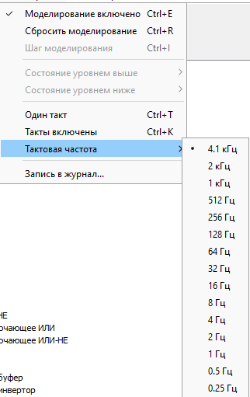

Figure 2

In order to start the game, you first need to turn on the clock. This is done in the internal interface of Logisim. To do this, select the clock speed of 4.1 kHz and start the clock cycles with the appropriate menu item, or by pressing Ctrl+K.
You also need to enable modeling using the menu option, or by pressing Ctrl+E if it is not already enabled. You can see an example of how it looks in the Russian version of the interface on figure 2.

Next, let's go to the MAIN diagram in order to consider the user interface. (Figure 3)
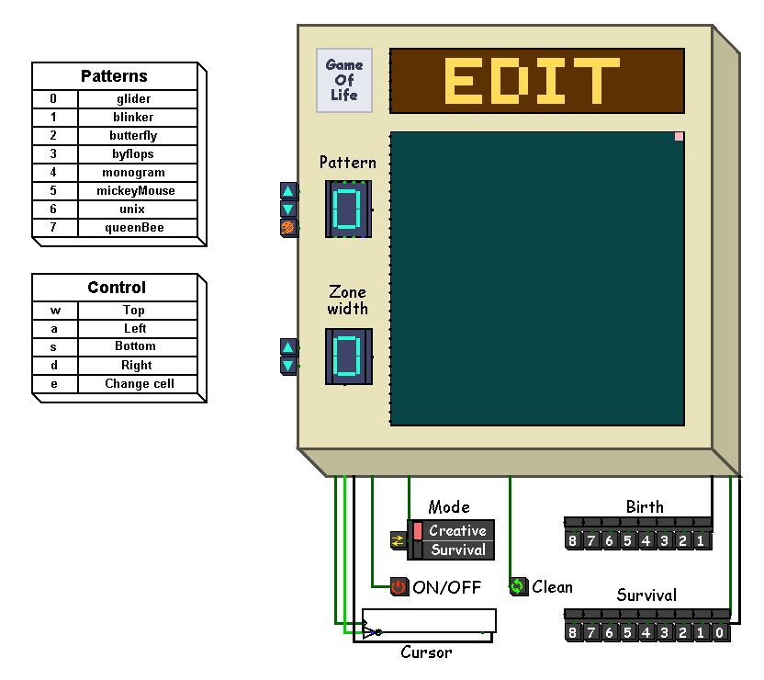
Figure 3

In order to start the game, you first need to set up the primary generation. To do this, select the keyboard, and then enter the characters, depending on what we want to get:

w - move one cell up

s - move one cell down

a - move one cell to the left

d - move one cell to the right

e - changing the state of the current cell
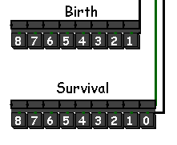
Figure 4

On figure 4, you can see the elements responsible for setting birth condition and survival condition, which can be changed. Each unit in these elements means the number of neighbors that will affect the reproduction of effects of the same name as the elements.
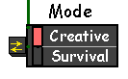

Figure 5.1

After setting the conditions, you can change the game mode (Figure 5.1). There are two game modes, they have already been described in detail. Let's just remind you that survival is a narrowed-field mode, while creative is a closed-field mode with a constant size.

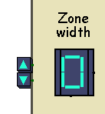
Figure 5.2

Zone width (Figure 5.2) - shows how much the NxN field will decrease in survival mode. The same Z from the finite square formula ((N-Z)x(N-Z)).
Next, just press the ON/OFF button to start/stop the generation. The generation may take time, be patient!
If you want to clear the field and start over, then click on the Clear button.
There are also patterns in the game. First, let's look at the data patterns control panel:
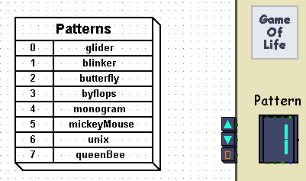
To add a pattern, move the cursor to the point where you want to place the pattern, and then click the set pattern button to the left of the pattern number selection.
Hardware

I/O Interface

On Figure 6-9, you can see the interface between hardware and software. They are connected to the bus and the processor accesses them instead of RAM when requesting certain memory locations (we'll look at which cells in the software part of the project). Let's take a closer look at what they do and what they are responsible for.

On Figure 6:
- Input row (Y) - Responsible for the Input Y coordinates for the cell.
- Input row (X) - Responsible for the Input X coordinates for the cell.
- Game state - Transmits information about whether the game is in progress.
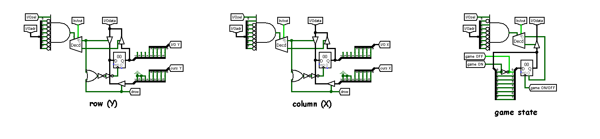
Figure 6
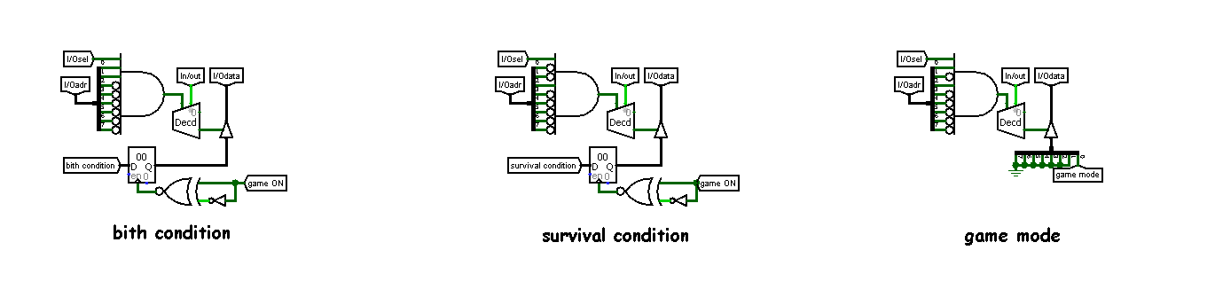
Figure 7

On Figure 7:
- birth condition - passes the value of the constant to the processor
- survival condition - it works similarly to the birth condition, but for a different constant.
- game mode - transmits to the processor the game mode that the player has chosen (survival or creative)
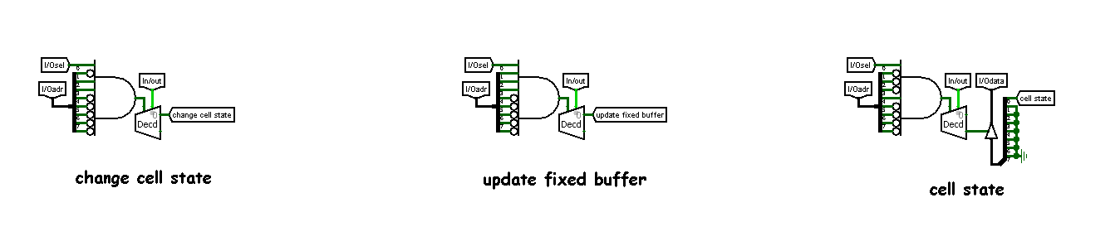
Figure 8
On Figure 8:
- change cell state - this I/O port is responsible for changing the state of the currently selected cell to the opposite.
- update fixed buffer - responsible for recording the current state in the fixed buffer
- cell state - transmits information about the current cell to the processor

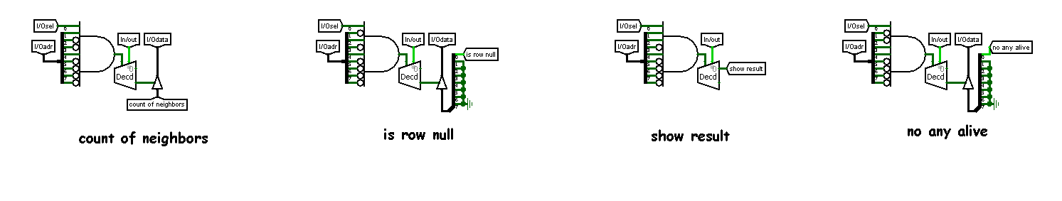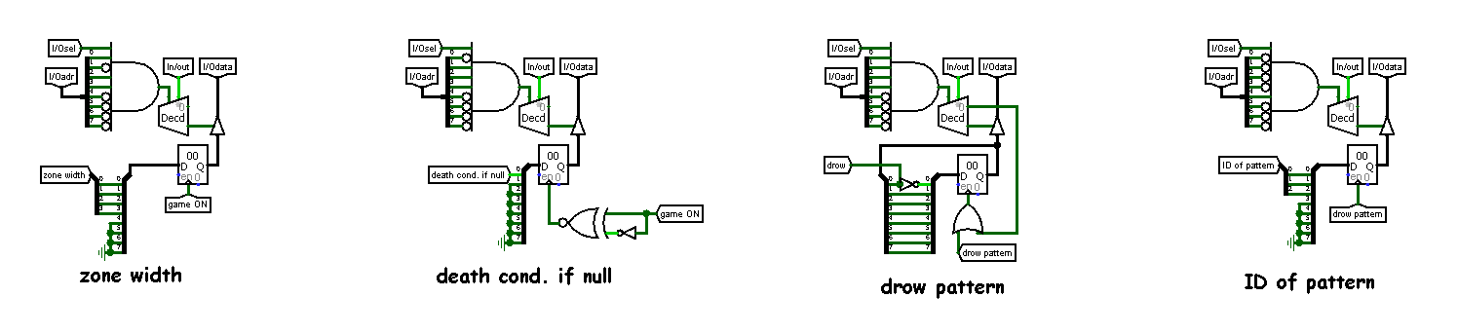
Figure 9-10

On Figure 9-10:
- count of neighbors - transmits to the processor the number of neighbors of the current cell.
- is row null - indicates whether the current line can be skipped.
- show result - a flag required for the status bar to show win/lose
- no any alive - it shows that absolutely all cells are dead (there is nothing more to count)
- zone width - this parameter is responsible for narrowing the zone in survival mode. The higher the number, the greater the number of narrowings.
- deathCondifNull - the condition of death if there are no neighbors

Buffers

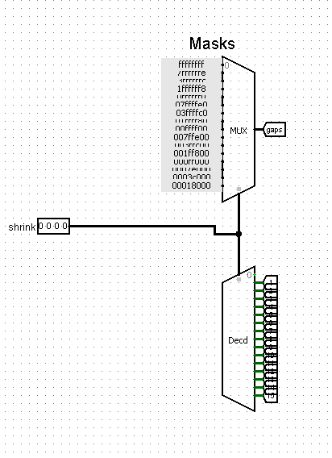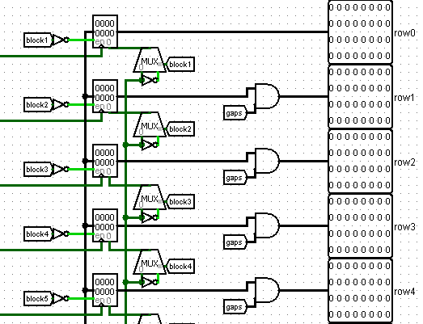
Figure 11-12

On figure 11-12, you can see the write buffer, which works with masks and multiple registers storing information. You can write to it, and you can also read from it. It is mainly used to provide a place to save information when calculating a new generation.

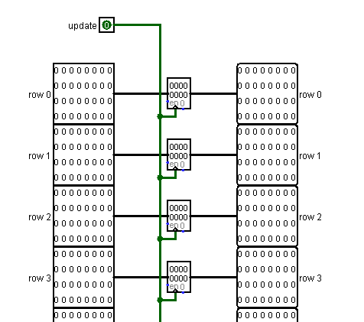
Figure 13

In figure 13, you can see the fixed buffer. Why is it called that? Because when requested from the processor, it simply stores all the information that is currently in the writebuffer. It is also needed to calculate the next generation, as well as to stabilize the calculation process.

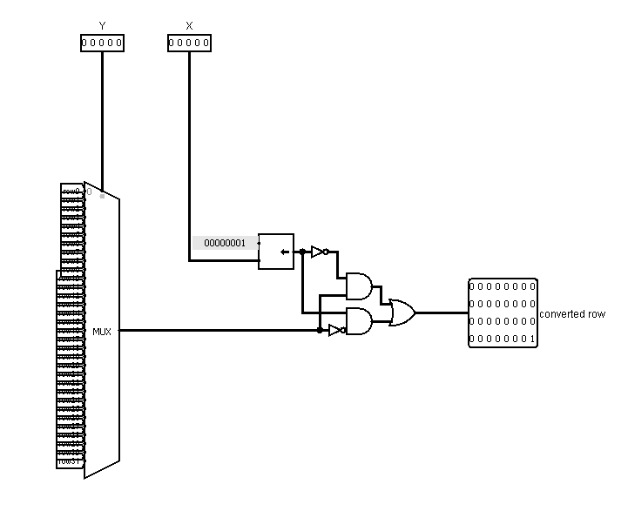
Figure 14

On figure 14, you can see the converter that is needed to changing the current state of the cell by X Y to the opposite.

Cursor
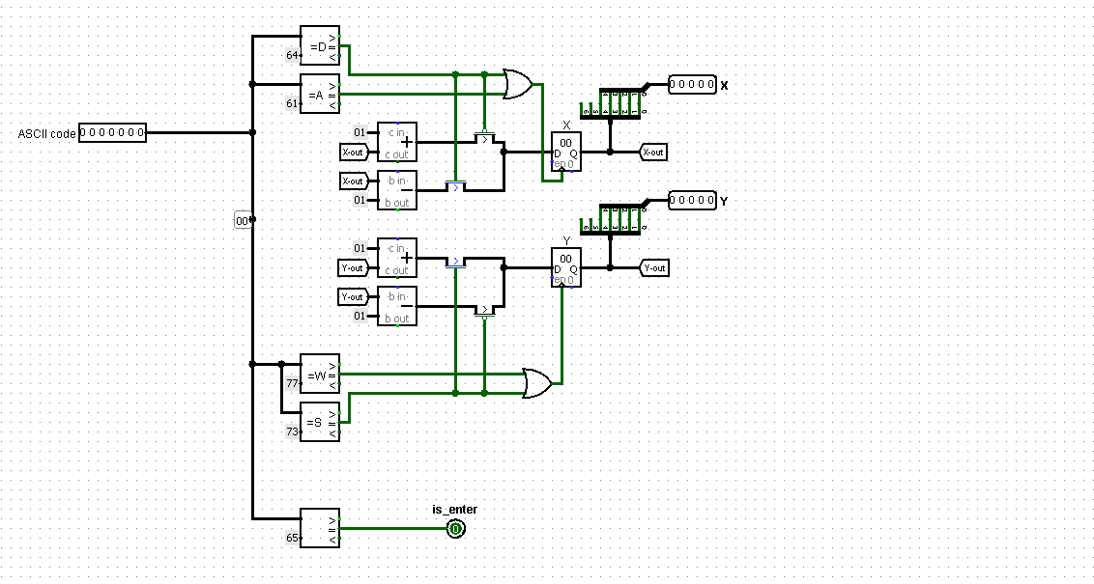
Figure 15
The cursor is a circuit that controls a blinking square to adjust the initial field. That's how it works.:
Figure 15. This scheme controls the cursor using the keyboard. Depending on the command that came to the keyboard, it performs actions. WASD - moving (a - to the left, w - up, s - down, d - to the right), and pressing the E -button sends a signal to set up a live cell.
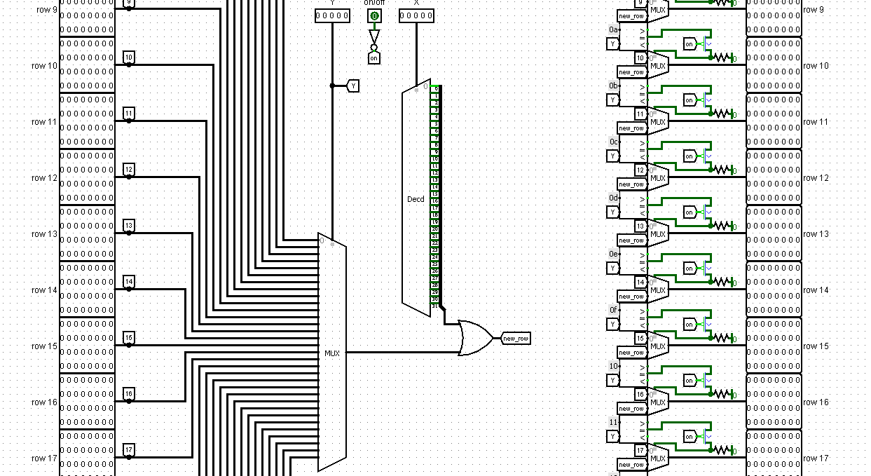
Figure 16

Figure 16. This scheme describes nothing more than the display of the cursor on the screen. He gets X Y as an input, and as a result, he simply sets the corresponding cell highlighted.

Subschemes

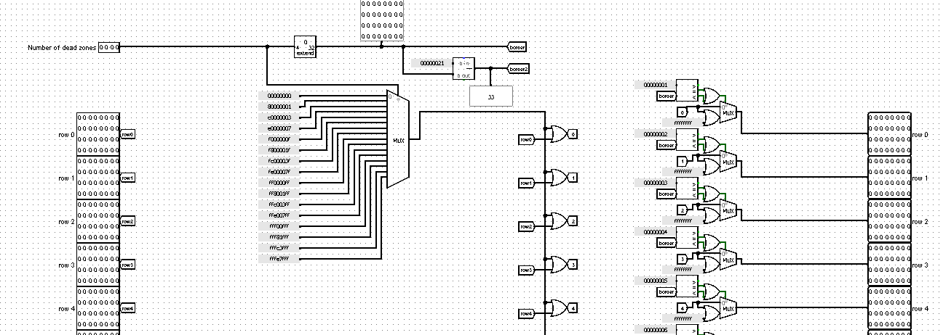
Figure 17

Figure 17. This scheme implements the display of a narrowed part of the field, due to the fact that the user is in survival mode. Based on the Number of dead zones and masks for MUX, it shows the dead parts of the field on the screen.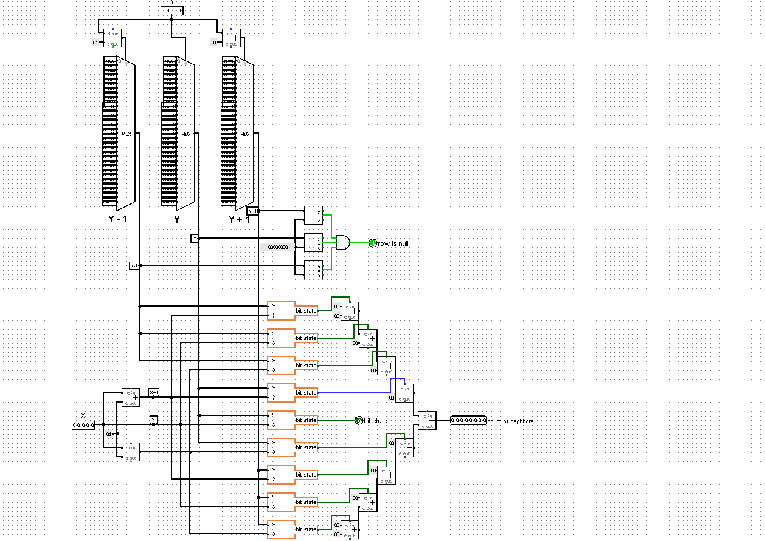
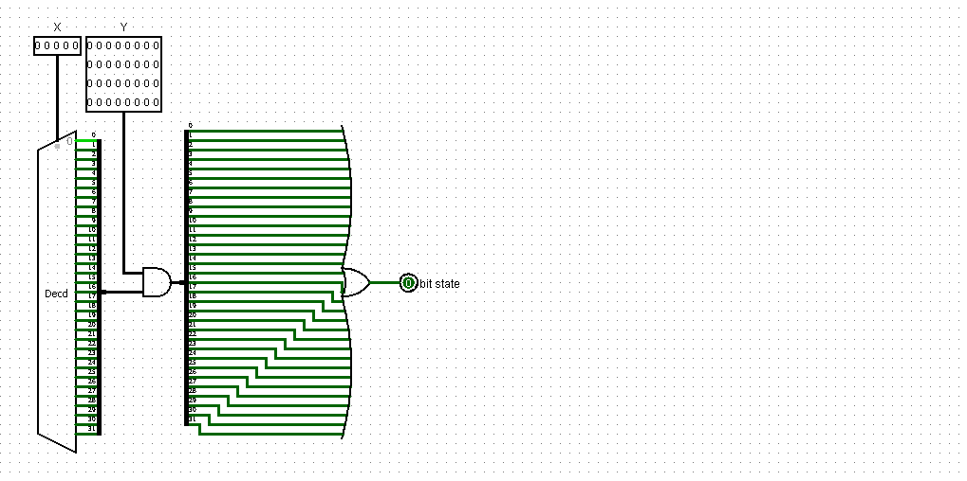
Figure 18-19

Figure 18. This scheme counts the number of neighbors of the specified cell. The sub diagram in the second picture just checks the condition of the cell by coordinates. And already the main cell takes the target cell and allocates all its neighbors. And then it is transferred to the sub scheme. Next, the state is calculated in it and the sum of such states is calculated. And it is already being transmitted to the output.

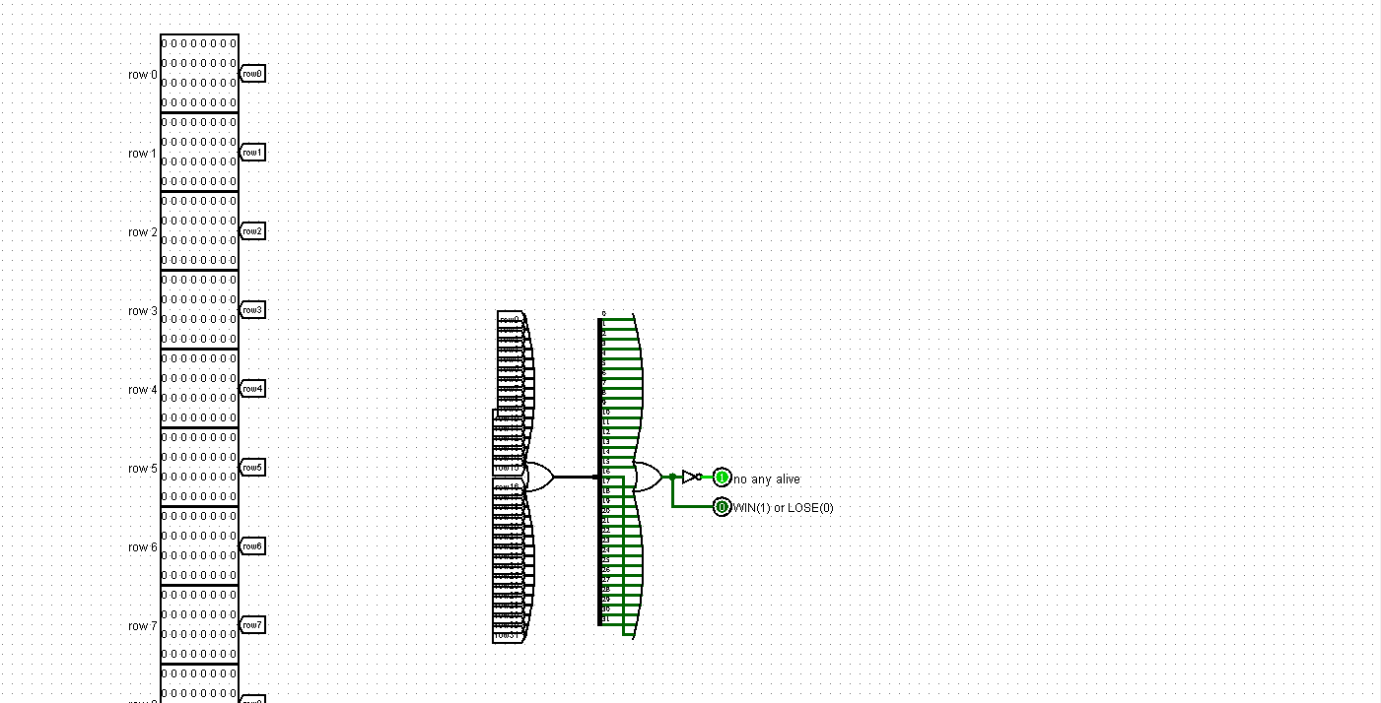
Figure 20

Figure 20. In this scheme, the number of living cells in the field is simply calculated. If there are none, then it makes no sense to count the next generations. This means that you can send a signal about this to the output. No more than that.
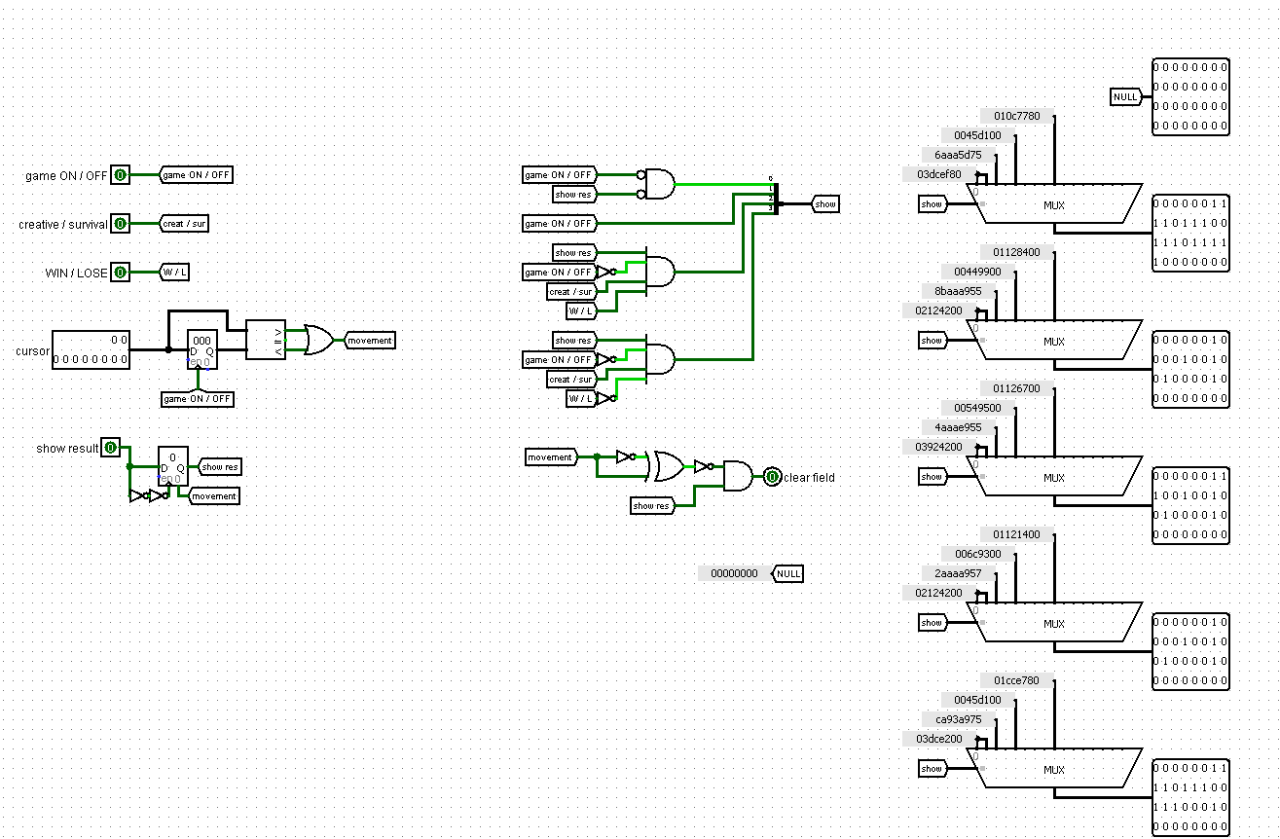
Figure 21

Figure 21. This scheme controls the upper screen above the main playing field. This screen can display multiple images. Edit - during editing. Simulation - during the miscalculations of the new generations of the game of life. Lose - if a person has lost a game in survival mode (this happens if there are no living cells in the final square). Win - win - if there is at least one live cell left in the survival mode (in the final square after decreasing).

Software

Memory sections

Description of the main memory sections in the code. These sections are mostly I/O interfaces and were described in the Hardware part.

anyChangesFlag - This flag indicates whether there have been any changes in the state of the field during the last generation.

minBound - upper left border of field

maxBound - lower right border of field

IO_X, IO_Y - Coordinates of the current cell

gameState - 1 start, 0 end the game

IObirthCondition - Number of cells nearby for birth

IOsurvivalCondition - The number of cells nearby for survival

gameMode - 0 creative, 1 survival

changeCellState - Cell inversion signal

updateFixedBuffer - Refresh the screen (Because the fixed buffer is displayed directly on the screen)

cellState - Current cell status (1 or 0)

countOfNeighbors - Number of living neighbors

isRowNull - indicates whether the current line can be skipped.

showResult - it is necessary for the status bar to show the win/lose result.

noAnyAlive - A flag that indicates that there are no more living cells.

zoneWidth - The width of the zone for survival mode.

deathCondifNull - the condition of death if there are no neighbors

drowPattern - drawing a pattern

IDofPattern - Pattern ID

Labels referring to functions (we will refer to them as function labels for ease of understanding):

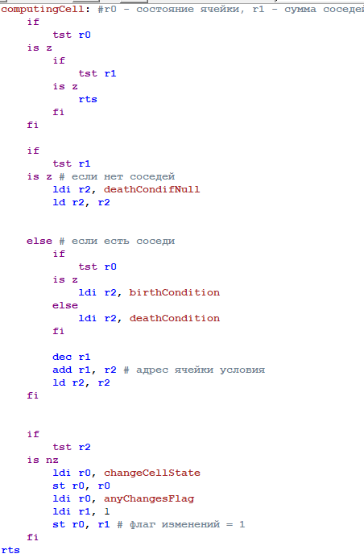

computingCell - This tag function changes the state of the cell, if required (checks the neighbors, the state of the cell itself, changes if necessary)

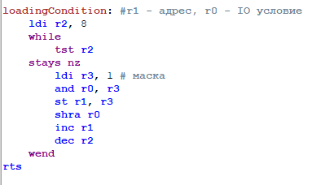
loadingCondition - Loads an 8-bit value from I/O (for example, IObirthCondition), decrypts it into 8 memory locations (birthCondition) bitwise.

Main code

Although the main code is also a label (and also contains labels), we will still put it in a separate block because this is a very large piece of code that needs to be described separately.
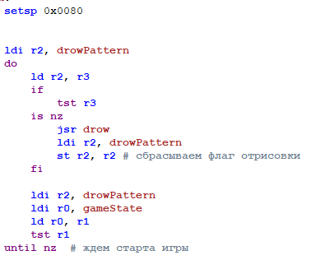
To begin with, we just wait for the game to start (just waiting for the button to be pressed).
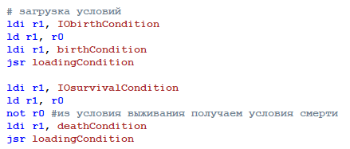
Then, when the game starts, we get the conditions for the appearance and survival of cells and record them.
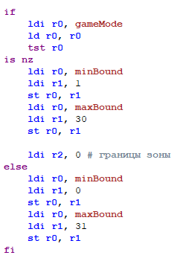
Next, we adjust the boundaries, depending on which gameMode we have. If creative is set, then we set from 0 to 31, if survival is set, then we set from 1 to 30 (because the extreme borders are already filled with a dead field anyway).
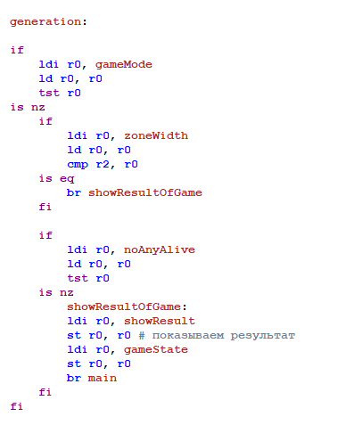
Next comes the processing code for each generation. Conditions for exiting this code:
1) The zone Width has reached its maximum (when playing survival)
2) There are no living cells left

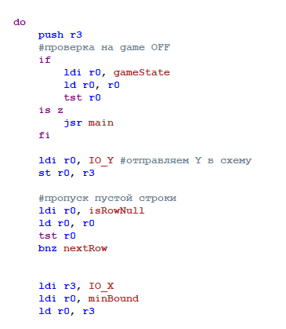
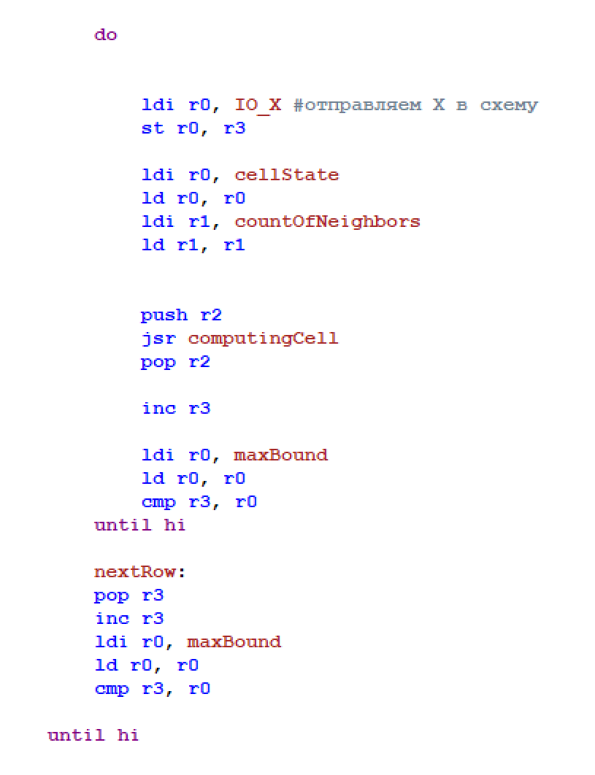
There are also some optimizations. For example, during the generation of a new turn, we don't even check the rows where (if the row number is N) N-1 and N+1 rows are completely empty, as is row N. Then we won't even count this line, and we'll write it as empty in the result, because there's no one to change it.

Patterns

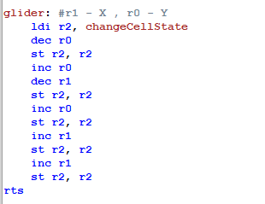
All patterns in the game are recorded as labels of this type. There are also pattern labels in the game such as:
- glider
- blinker
- butterfly
- byflops
- monogram
- mickeyMouse
- unix
- queenBee

